1) Watch the terraform-02 video.
2) Execute all the templates shown in video.
3) Integrate terraform in Jenkins using Terraform plugin.

1) Watch the terraform-02 video.

Completed.

2) Execute all the templates shown in video.

Providers:

- Official provided by terraform
- Partner provided by third party vendors
- Community individual who can create

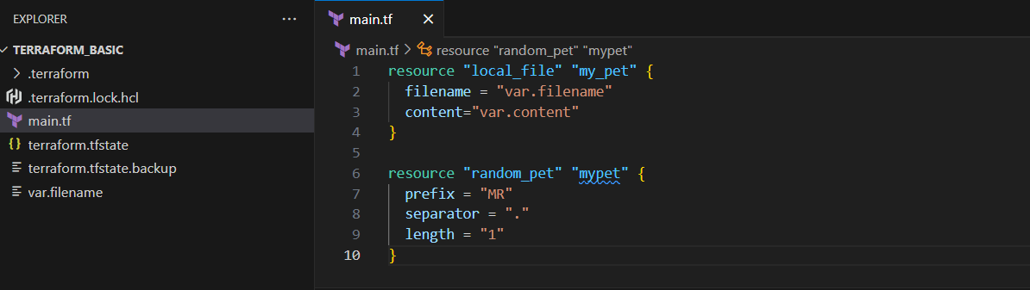

Configuration Directory:

Main.tf -->main configuration file containing resource definition
variables.tf --> contains varibles declaration
output.tf --> contains outputs from resources
provider.tf --> contains the provider definition

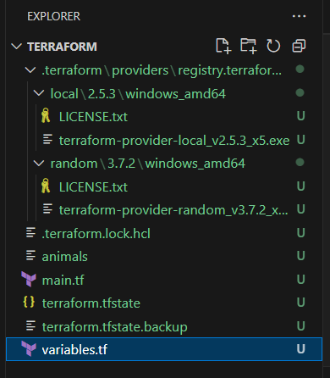

Terraform mutable vs immutable infrastructure:

Terraform as a IAC tool uses immutable infrastructure strategy.
Immutable means deleting the older infra and creating a newer one with a new update.
Mutable means using the existing infra and updating the system with newer versions.

Lifecycle rules:

We can configure lifecycle rules to our resource file.
Terraform will destroy the file before creating a new file by default.
We can create a file before destruction by using the lifecycle rules.

resource "local_file" "pet" {
filename = "/root/pets.txt"
content = "My cat is MR.CAT"

lifecylce {
create_before_destory = true
}
}

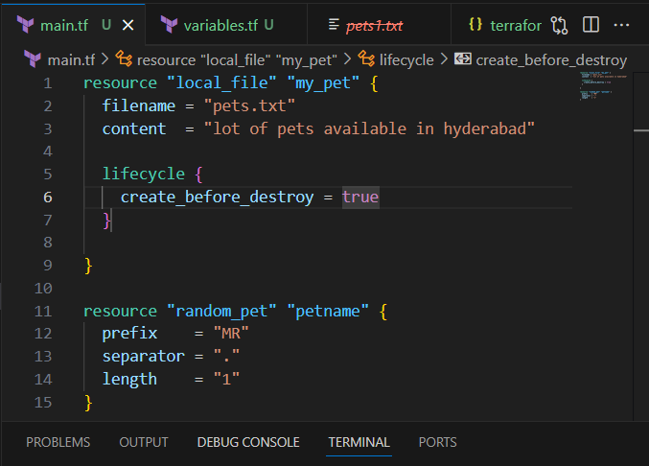

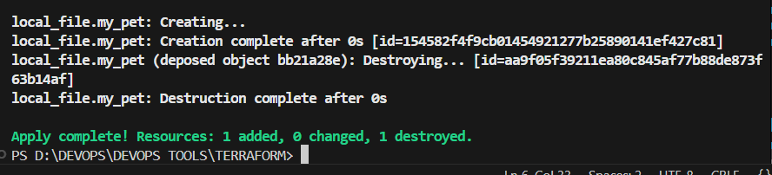

lifecycle {
prevent_destroy = true
}

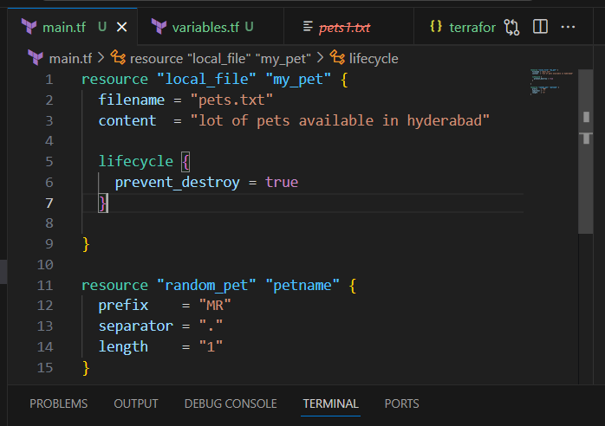

If going to change content and doing terraform apply it will stops.
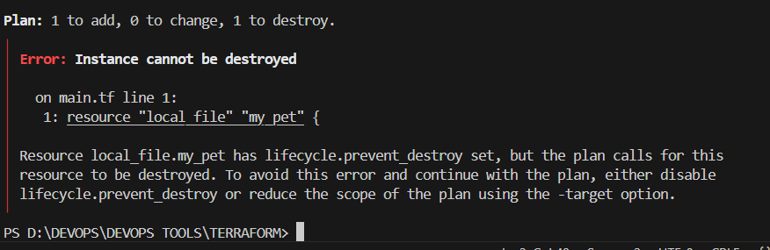

lifecycle {
ignore_changes = [ content ]
}

If do changes then it will ignore and remain same.

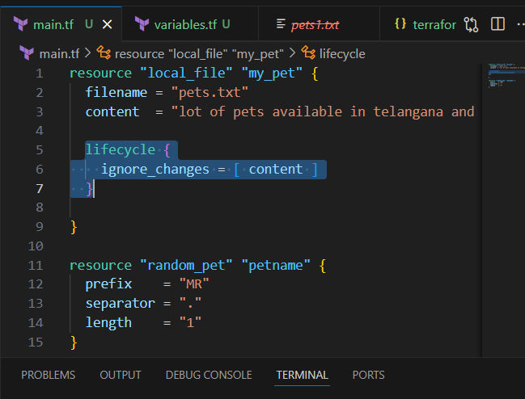

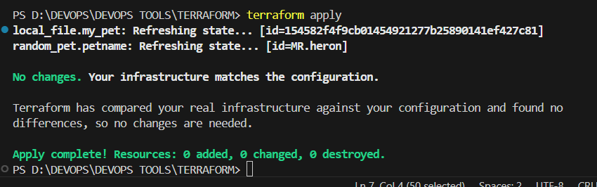

Variables

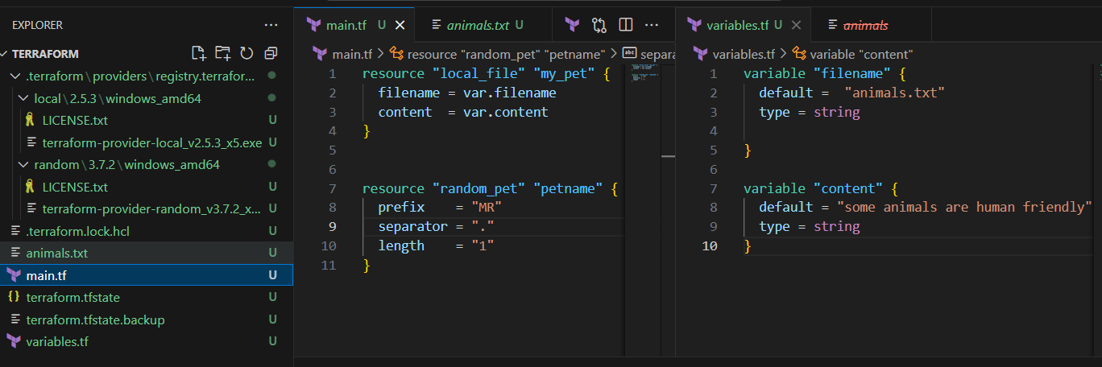

resource "local_file" "my_pet" {
filename = var.filename
content = var.content
}

resource "random_pet" "petname" {
prefix = "MR"
separator = "."
length = "1"
}

variable "filename" {
default = "animals.txt"
type = string

}

variable "content" {
default = "some animals are human friendly"
type = string
}

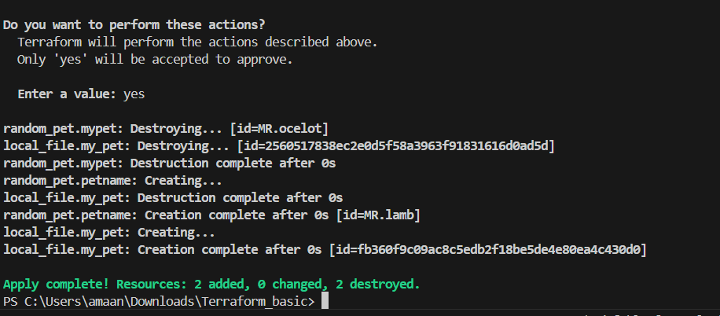

Taking user input

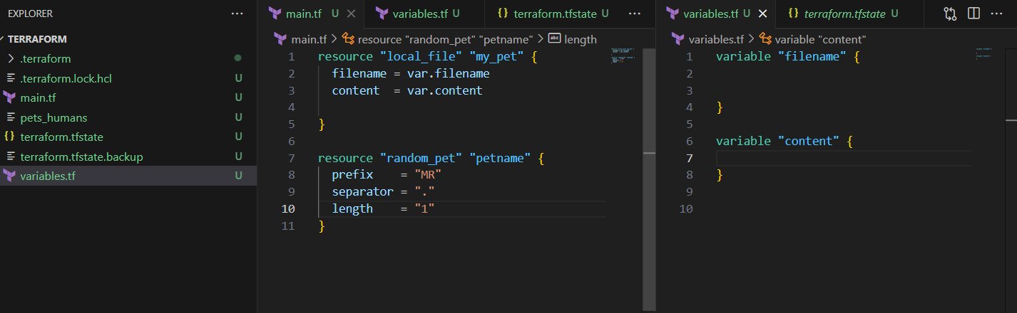

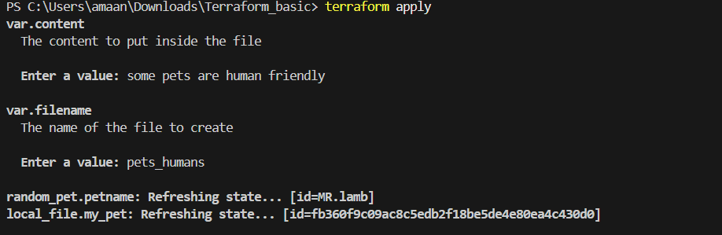
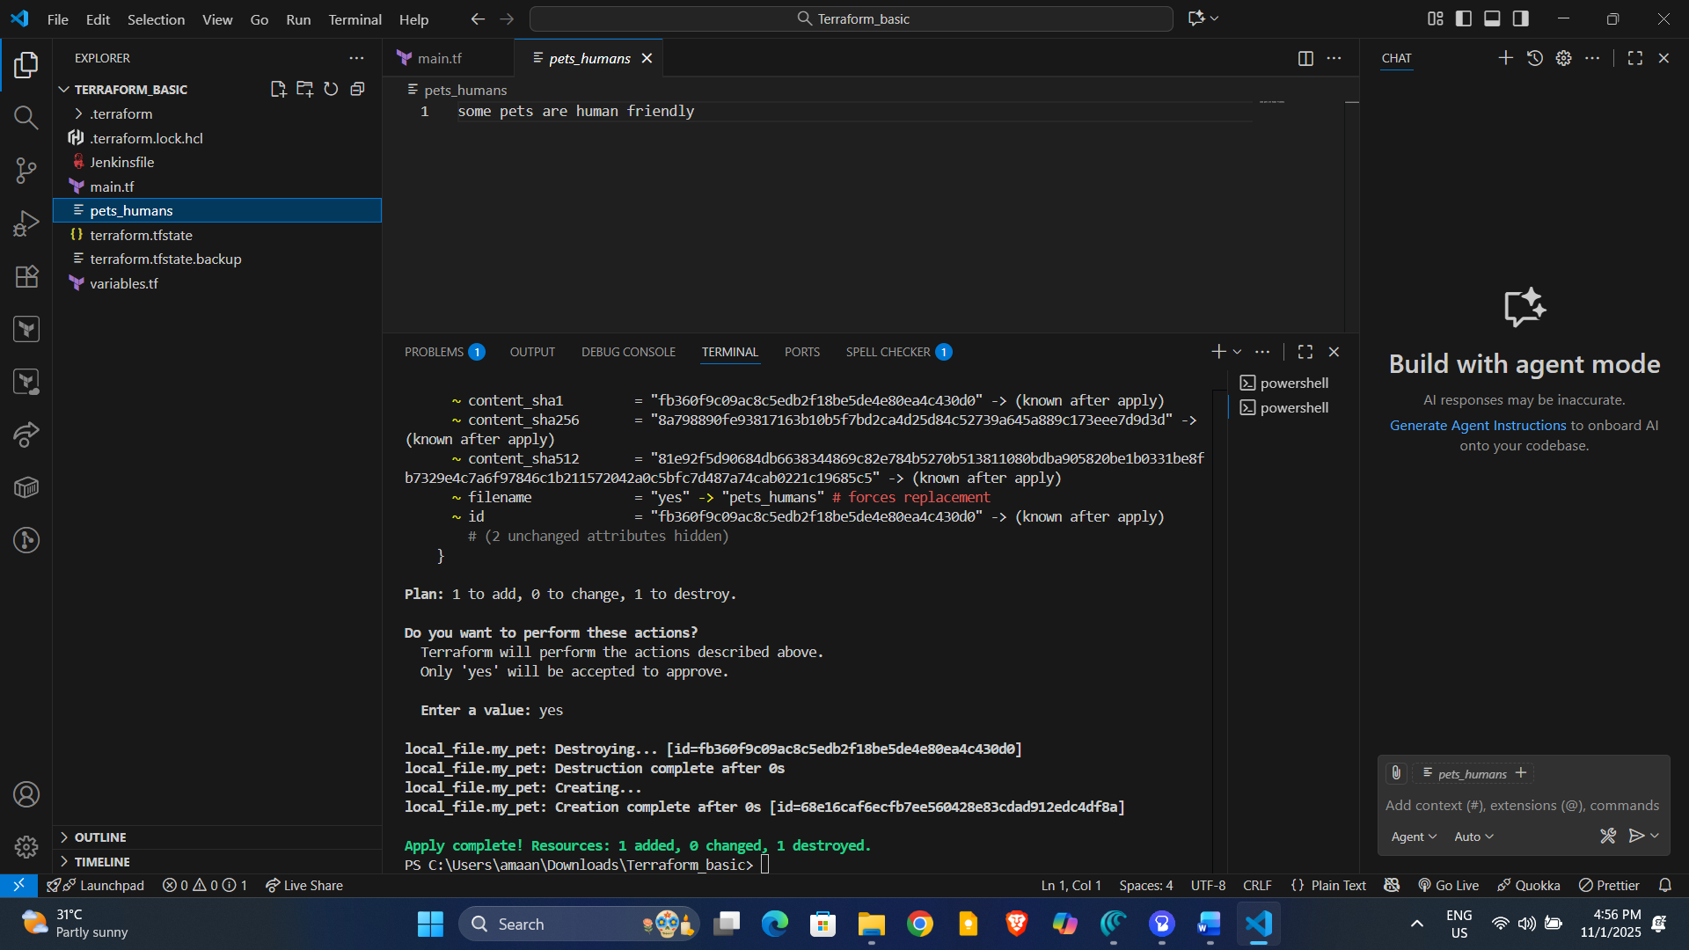

Passing values using command

terraform apply -var "filename=pets.txt" -var "content=some of the pets are cats, chicks"

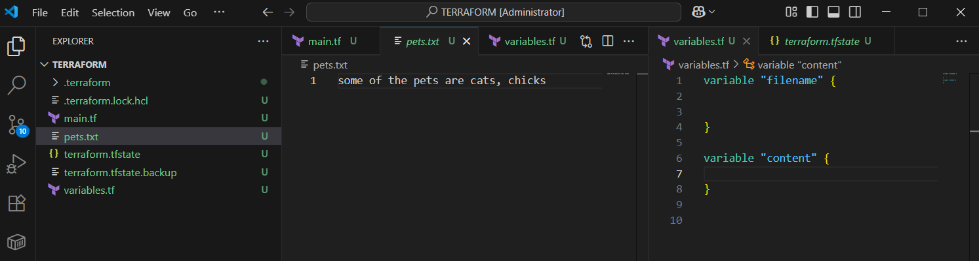

terraform apply -var "filename=animals" -var "content=earth running with huge number of animals"

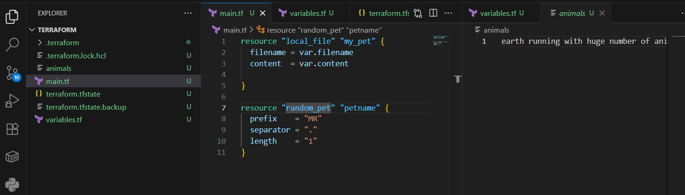

3) Integrate terraform in Jenkins using Terraform plugin.

- Jenkins ec2 launched , git, java, jenkins installed.
- In jenkins master terraform plugin installed.
- Installed terraform
# Download latest version (Linux 64-bit)
wget https://releases.hashicorp.com/terraform/1.13.1/terraform_1.13.1_linux_amd64.zip
# Unzip and move
unzip terraform_1.13.1_linux_amd64.zip
sudo mv terraform /usr/local/bin/
# Verify
terraform -v

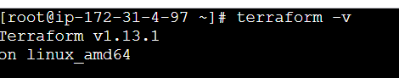

4. Using git repo 1 job created in jenkins master.

https://github.com/Mohammed-Amaan-Ahmed/terraform.git

5. Declarative script taken in Jenkinsfile of the github repo.

📘 Jenkins + Terraform + Slack Integration Documentation

🔹 1. Prerequisites
- Jenkins Server installed and running.
- Terraform CLI installed on Jenkins (or configured via Jenkins tools).
- GitHub Repository with Terraform files (main.tf, variables.tf, Jenkinsfile).
- Slack Workspace with an incoming webhook or Slack App.

🔹 2. Configure Jenkins

(a) Install Required Plugins
- Go to Manage Jenkins → Plugins → Available Plugins.
- Install:
  - Terraform Plugin
  - Pipeline Plugin (if not already installed)
  - Git Plugin
  - Slack Notification Plugin, stage view plugin

(b) Add GitHub Repo
- Create a Pipeline Job in Jenkins → “New Item → Pipeline”.
- Configure:
  - Select Pipeline script from SCM.
  - SCM: Git → Enter repo URL:
https://github.com/Mohammed-Amaan-Ahmed/terraform.git
Branch: main.

(c) Configure Terraform in Jenkins
- Go to Manage Jenkins → Global Tool Configuration.
- Add Terraform installation:
  - Name: Terraform
  - Version: 1.13.1
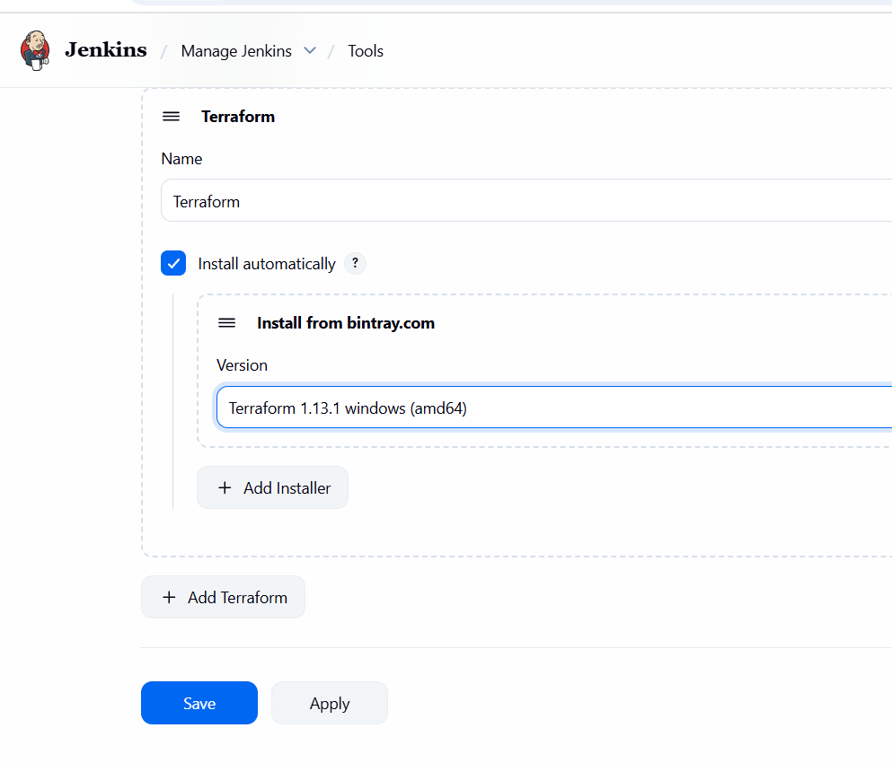

(d) Configure Slack in Jenkins
- In Slack:
  - Go to Slack API → Create App → Bots → Incoming Webhooks.
  - Add Jenkins to your channel.
  - Copy the Webhook URL or Token.
- In Jenkins:
  - Go to Manage Jenkins → Configure System → Slack.
  - Add:
    - Workspace: your Slack workspace
    - Channel: #jenkins-alerts (or your channel)
    - Integration Token: Save it in Jenkins Credentials (Secret Text).
  - Note the Credential ID (e.g., slack-token).

🔹 3. GitHub Repo Structure
Your repo should look like this:
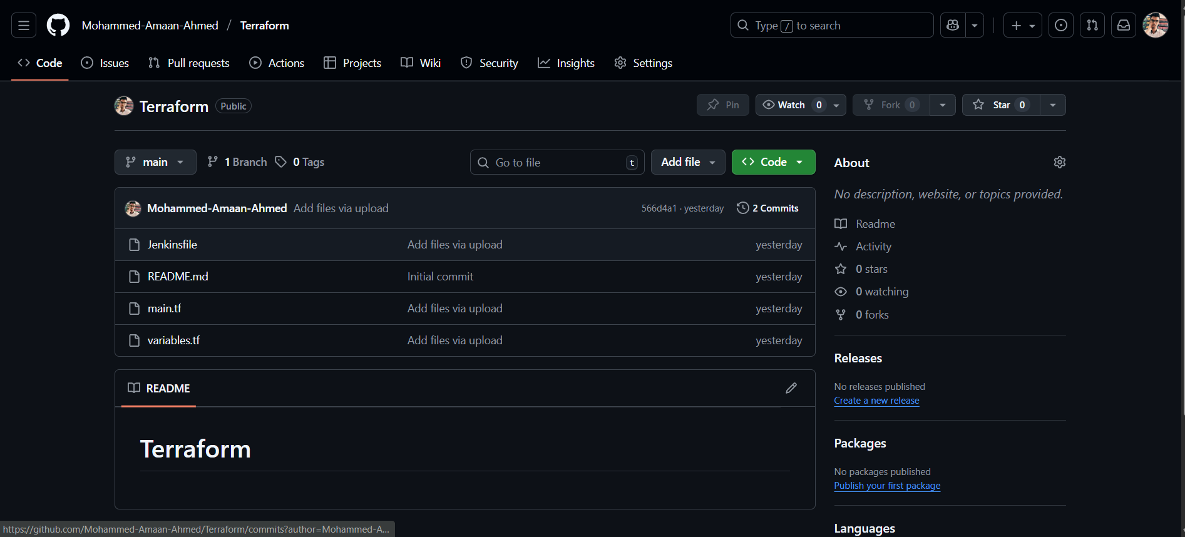

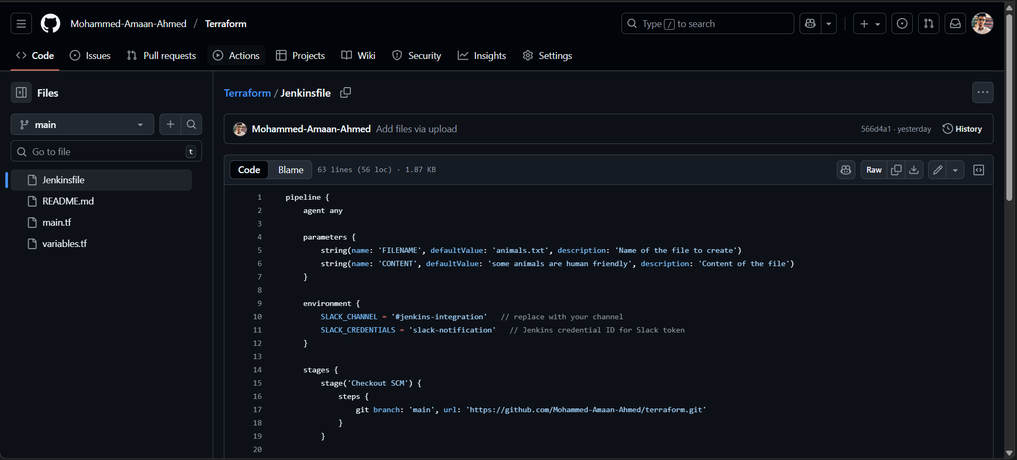

main.tf
resource "local_file" "my_pet" {
filename = var.filename
content = var.content
}

resource "random_pet" "petname" {
prefix = "MR"
separator = "."
length = 1
}
variables.tf
variable "filename" {
description = "The name of the file to create"
type = string
}

variable "content" {
description = "The content to put inside the file"
type = string
}

🔹 4. Jenkinsfile (Pipeline Script)

pipeline {
agent any

parameters {
string(name: 'FILENAME', defaultValue: 'animals.txt', description: 'Name of the file to create')
string(name: 'CONTENT', defaultValue: 'some animals are human friendly', description: 'Content of the file')
}

environment {
SLACK_CHANNEL = '#jenkins-integration' // replace with your channel
SLACK_CREDENTIALS = 'slack-notification' // Jenkins credential ID for Slack token
}

stages {
stage('Checkout SCM') {
steps {
git branch: 'main', url: https://github.com/Mohammed-Amaan-Ahmed/Terraform.git'
}
}

stage('Terraform Init') {
steps {
sh 'terraform init'
}
}

stage('Terraform Plan') {
steps {
sh """
terraform plan -out=tfplan \
-var="filename=${params.FILENAME}" \
-var="content=${params.CONTENT}"
"""
}
}

stage('Terraform Apply') {
steps {
input message: "⚠️ Do you want to apply Terraform changes?"
sh 'terraform apply -auto-approve tfplan'
}
}
}

post {
success {
echo "✅ Terraform executed successfully. File: ${params.FILENAME}"
slackSend (
channel: "${env.SLACK_CHANNEL}",
color: '#36a64f',
message: "✅ Terraform executed successfully!\n*File:* ${params.FILENAME}\n*Content:* ${params.CONTENT} (By Imran Khan)"
)
}
failure {
echo "❌ Terraform pipeline failed!"
slackSend (
channel: "${env.SLACK_CHANNEL}",
color: '#FF0000',
message: "❌ Terraform pipeline failed!"
)
}
}
}

🔹 5. Run the Pipeline
- In Jenkins, run the pipeline job.
- Provide parameters (filename, content) if asked.
- Jenkins will:
  - Checkout Git repo
  - Run terraform init
  - Run terraform plan with variables
  - Wait for manual approval
  - Run terraform apply
  - Send success/failure message to Slack.

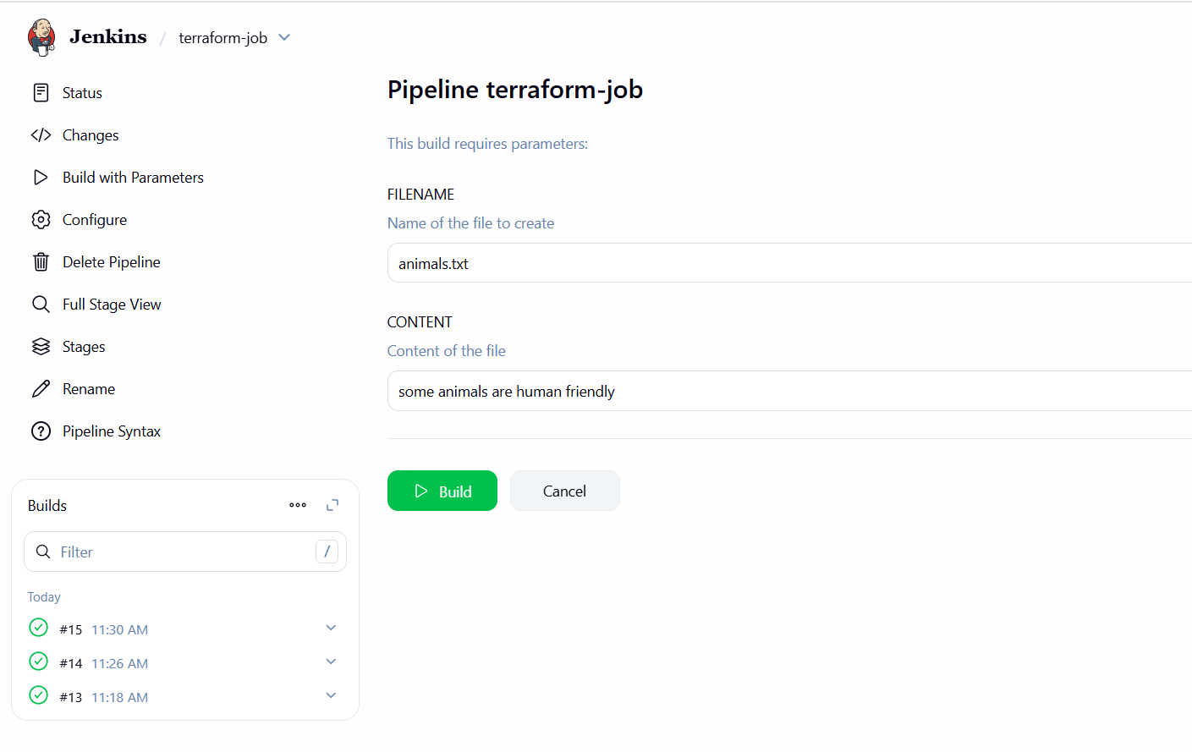

While running build, jenkins stop the job at apply stage need to open console output and click on proceed or abort.

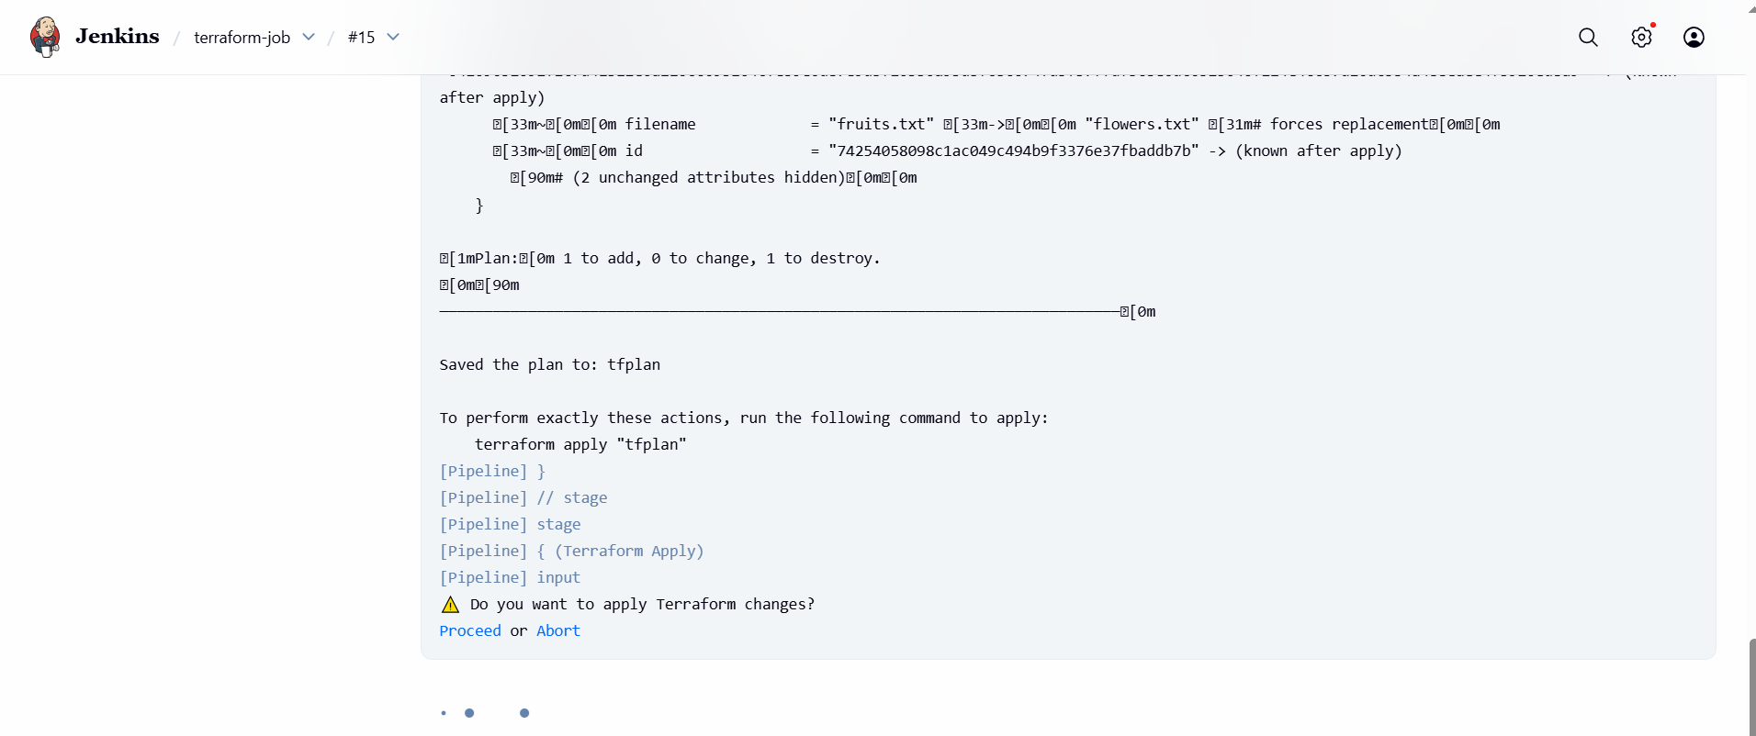

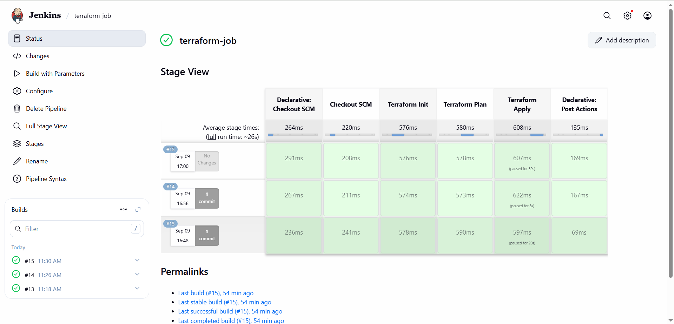

🔹 6. Verify the Output
- The file (flowers.txt) will be created inside the Jenkins workspace:
/var/lib/jenkins/workspace/terraform-job/animals.txt
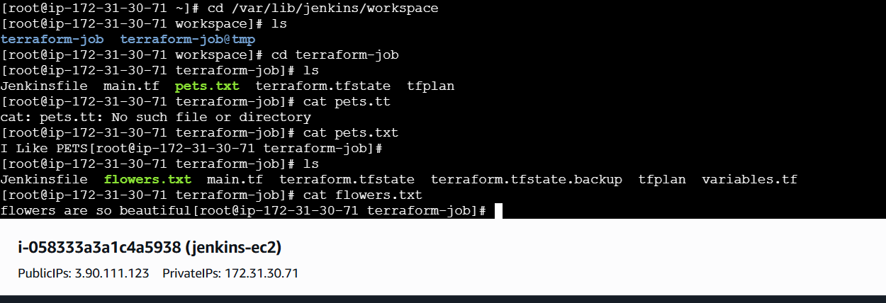
Slack channel will receive:
